SCM Notes | Session 1: Fundamentals of Supply Chain
Course: Supply Chain Digitization

1. What is a Supply Chain?
- Definition: An interconnected journey of raw materials, components & finished goods — from origin (before their assembly) to sale to the customer.
- The word "chain" = series of links → each link = a player/entity in the SC
- Purpose: Ensure products are manufactured & reach the final customer — right time, right quantity, right quality
Key Players (in order):
- Raw Material Supplier → Manufacturer → Warehouse → Distributor → Retailer → Customer
- Product moves in different forms & shapes at each stage
Role of each link:
- RM Supplier: deliver raw material → right time, qty, quality
- Manufacturer: convert RM → finished goods
- Warehouse / Distributor / Retailer: move product closer to end customer
⚠ Key Takeaway: Not all supply chains are the same — structure depends on product type & business model.

2. Types of Supply Chains — Examples

(a) Automobile SC
- Complex, multi-tier SC with 1000+ raw material suppliers
- Flow: RM Suppliers → Sub-component Mfg → Interior / Powertrain Assemblers → Final Assembly → Dealers → Consumers
- Sub-components: dashboards, transmission, engine (each needs dedicated suppliers)
- Final assembly: ~1000 unique components assembled at this stage
- Distribution: can have multi-layer distribution centres between assembler & dealers (depends on geography)
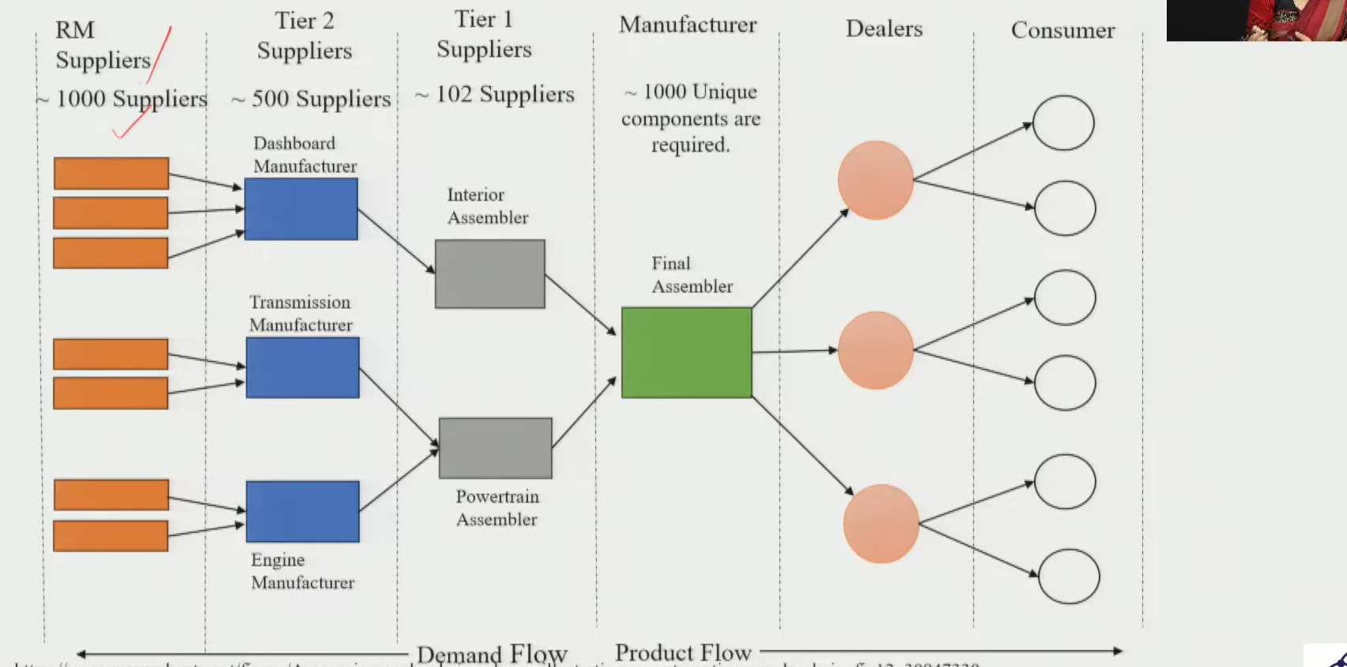

(b) Pharmaceutical SC
- Two key input types: (1) Raw Materials (RM) + (2) Packaging Materials (PM)
- Flow: RM/PM Suppliers → Manufacturers → Central Warehouse → Distributors / Stockists / Semi-Wholesalers → Retailers / Pharmacies / Hospitals → Consumers
- Critical triad: RM Supplier ↔ Manufacturer ↔ R&D (R&D drives updated product requirements → feeds back to suppliers)
- Inbound logistics via rail & road; exports handled by export agents + C&F agents
- Network is complex/jumbled — necessary to reach patients at every last-mile point
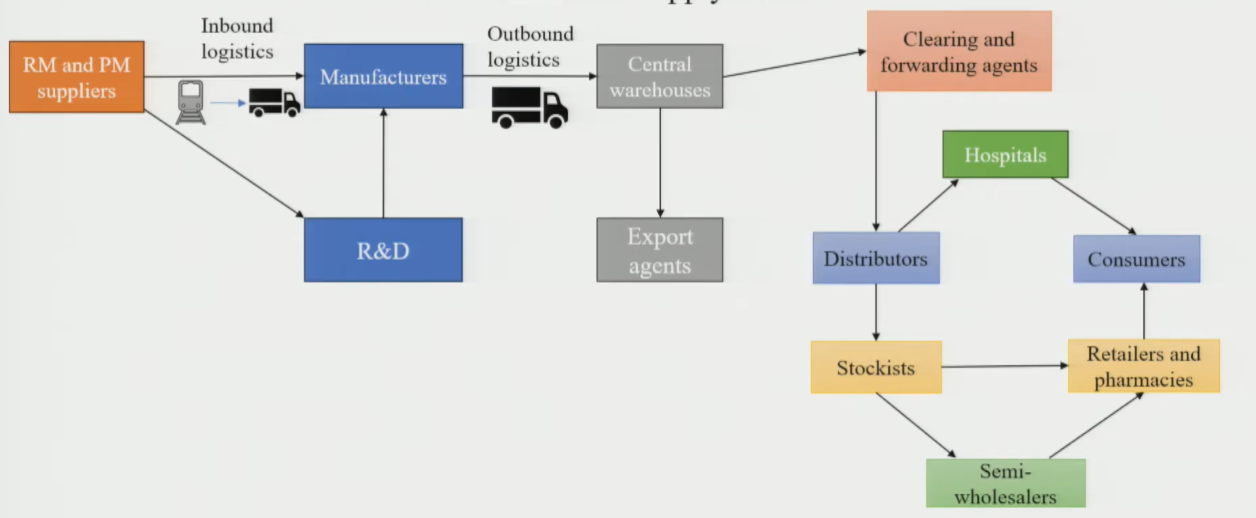

(c) Oil & Gas SC
- Flow: Exploration → Production → Crude Oil Storage → Refinery (distillation etc.) → Storage Terminals → Retail / Industrial / Commercial Markets
- Distinctive feature: transportation mode changes at each stage:
- Exploration → Production: pipeline or ship
- Refinery → Storage Terminals: pipeline or ship
- Storage Terminals → End Markets: pipeline / rail / road / tanker
- Processing method & storage format also change across stages
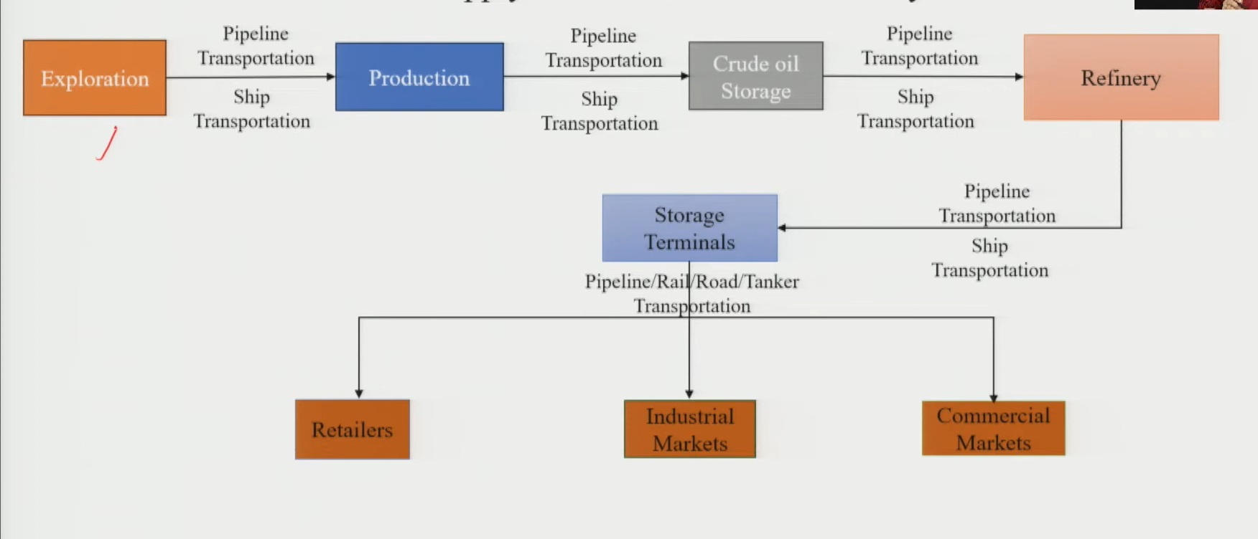

(d) E-Commerce SC
- Flow: Customer Order → 3PL (Third Party Logistics) Central Warehouse → Supplier → 3PL Central Warehouse → 3PL Local Warehouse → Last-Mile Delivery → Customer
- Two parallel flows:
- Information flow (black/blue line): order details — product type, qty, price
- Physical flow (orange line): physical movement of goods
- Key difference vs. traditional SC: NO manufacturer or RM supplier visible in this SC — only product suppliers & 3PL
- Note: If you trace the supplier's SC, manufacturers & RM suppliers reappear — just outside scope of e-comm perspective
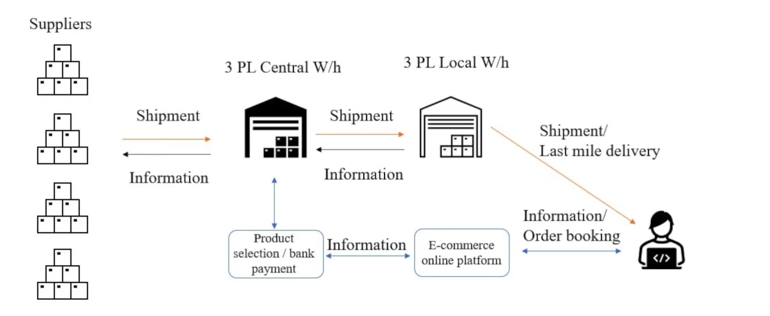

3. Key Concepts to Remember
- SC structure ≠ fixed → depends on product type, business model & geography
- Not every player is present in every SC (e.g., no manufacturer in e-comm SC; no RM extraction in e-comm)
- Number of tiers/layers → directly impacts complexity & coordination effort
- Good exercise: pick any product → trace its SC → identify each player & their role
Quick Comparison (for revision):
- Auto: most tiers, 1000+ suppliers, highest assembly complexity
- Pharma: R&D plays active role, last-mile reach is critical, complex distribution web
- Oil & Gas: unique transport modes (pipeline/ship), product transforms at refinery
- E-Commerce: info flow as important as physical flow, 3PL central, no in-SC manufacturing
✓ Exam Angle: "Explain with examples why all supply chains are not the same." — Use 2–3 examples above, highlight: players involved, transport modes, product transformation & information flow.

